

TASK 1
YEAR 11 ATAR PSYCHOLOGY
SEMESTER 1 2024 - UNIT 1

Science Inquiry & Biological Psychology

Name: ___________________

Syllabus points
- Science Inquiry: Ethical guidelines, formulating research, communicating
- Biological psychology

Conditions
- Reading time: 5 minutes
- Working time: 50 minutes

Task Weighting
- 10%

Structure of this paper

Section | Number of questions available | Number of questions to be attempted | Suggested working time  (minutes) | Marks | Score
Section One:  Science Inquiry | 1 | 1 | 15 | 12
Section Two:  Short Answer | 1 | 1 | 35 | 38
 |  |  | Total | 50

Section One: Science Inquiry 20% (12 Marks)

This section has one question. Write your answers in the spaces provided.
Suggested working time: 15 minutes.

Question one (12 marks)

The ability to recognise the intensity of emotions is an important social skill. Researchers from Jena University were interested in finding out whether neural activity increased more quickly when year 7 students are exposed to emotional or neutral facial expressions. Participants identified their responses to a series of photographs of people that showed neutral and emotional facial expressions. They used a mouse with their right hand to press a button to identify either emotional or neutral expressions. The researchers measured the speed of the responses.

- Write a directional hypothesis for this research study. (4 marks)
Description | Marks
Population = year 7 students | 1
Independent variable (emotional/neutral facial expressions) & dependent variable (speed of responses) | 1
Prediction = will/will not | 1
Measurement tool = exposure to facial expressions | 1
Total | 4
Example: It is hypothesised that year 7 students will identify photographs of emotional facial expressions faster than year 7 students who are exposed to neutral facial expressions.

Forty five participants were recruited into the sample based on recommendations from other participants in the sample group.
- Define the term ‘population’ in the context of psychological research. (1 mark)
Description | Marks
The complete collection of people that can possibly be measured in psychological research | 1
Total | 1

The study was approved by the Ethics Committee of the University of Jena and all participants gave informed consent prior to their participation.
- Describe the role of ethics in psychological research. (1 marks)
Description | Marks
Ethics are the moral principles and codes of conduct that must be abided by and apply to all psychologists. | 1
Total | 1

- Define the concept of informed consent and explain how a researcher should ensure informed consent is attained. (4 marks)
Description | Marks
Define informed consent (1)  - Participants agree to the full implications of participating in the research | 1
Describe what a researcher must do: Any two of the following (2)  - Explain nature and purpose of the study  - Clarify foreseeable risks/adverse effects  - Explain how information/data will be collected and recorded  - Explain where and for how long information/data will be stored  - Explain who will have access to stored information/data  - Advise participants of the right to withdraw  - Explain confidentiality and any limits to confidentiality  - Explain the research in plain language/language that is easily understood by the participants | 1 – 2
Applies to the scenario (1)  - A researcher needs to explain this to both the child and their parent/guardian | 1
Total | 4

The University of Jena wanted to publish the results of this research in a psychological journal.

- Outline the ethical concept that applies to publishing the results of this research (2 marks)

Description | Marks
Any one of the following:  - Confidentiality (1) = Data for individual participants must not be revealed without their consent (1)  - Privacy (1) = The participants personal information is not revealed (1) | 1 - 2
Total | 2

Section Two: Short Answer 80% (30 Marks)

This section has four questions. Write your answers in the spaces provided.
Suggested working time: 30 minutes.

Question two (14 marks)

Zendi is walking home from university at 10 pm at night. He could hear the rustle of the tree branches in the wind and hears footsteps behind him.

- Complete the following diagram to identify the structures of the human nervous system (4 marks)
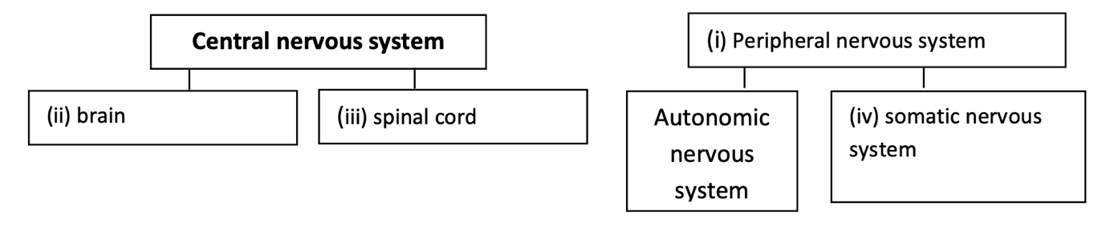

- Identify and describe the function of the neuron activated when Zendi hears the rustle of the tree branches. (2 marks)

Description | Marks
Sensory neuron | 1
Carry the sound of the rustling tree branches from the ears (periphery) into the central nervous system | 1
Total | 2

- Complete the table below to explain the role of each branch of Zendi’s autonomic nervous system responding to sensory stimuli as he walks home from university. (4 marks)

Branch | Role | Physiological response
Sympathetic | Emergency/arousal system that activates when a threat/danger is perceived | Any one of the following:  - Increased heart rate  - Increased blood pressure  - Dilated pupils  - Increased sweating  Accept any other relevant responses
Parasympathetic | Calms the body down and returns it to normal level of arousal (after threat has passed) to conserve energy | Any one of the following:  - Decreased heart rate  - Decreased blood pressure  - Contracted pupils  - Decreased sweating  Accept any other relevant responses

Question three (8 marks)

- Shade the hindbrain in the following diagram. (1 mark)

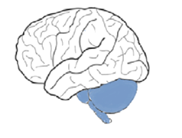

- State two functions of the cerebellum. (2 marks)

Description | Marks
Any two of the following:  - Coordinates voluntary muscle movements  - Coordinates balance  - Regulates posture  - Regulates muscle tone  Accept any other relevant responses | 1 - 2
Total | 2

- Describe the location and function of the following parts of the brain. (5 marks)

Part of the brain | Location | Function
Reticular formation | Midbrain | Determines which sensory information is important/unimportant/screens sensory information to be transmitted to the cerebral cortex
Primary motor cortex | Rear/back/posterior of the frontal lobe (next to the anterior parietal lobe) | Generates neural impulses that control movement
Occipital lobe | Back/posterior of the brain | Processes visual information
Question four (11 marks)

Dr Quinn has a patient who has suffered a stroke. The patient is also having difficulty recognising faces, and when asked to, they draw the below picture.
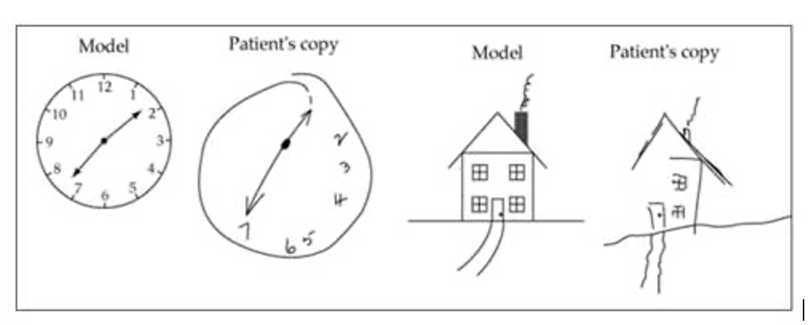
- Identify which hemisphere of the brain has been damaged. (1 mark)

Description | Marks
Right hemisphere | 1
Total | 1

- With reference to the symptoms, explain which lobe of the cerebral cortex has been damaged.
(3 marks)
Description | Marks
Occipital lobe | 1
Receives and processes visual information | 1
This is shown by the patient being unable to draw objects on the left side of a picture | 1
Total | 3

- Explain how electroencephalography (EEG) is used to investigate the patient’s brain damage.
(3 marks)

Description | Marks
An electroencephalogram (EEG) is an external recording technique used to measure brain waves or electrical activity in the brain | 1
Many small electrodes are placed on a patient’s scalp. | 1
It produces a graph that records the electrical activity. | 1
Total | 3

- Outline one strength and one limitation of electroencephalography in investigating brain damage. (2 marks)

Description | Marks
Any one of the following strengths:  - Is a non-invasive research technique  - Easily accessible and inexpensive.  - Can be used in a wide variety of situations and over lengthy periods.  - An EEG can be used on all patients, including infants and the elderly. | 1
Any one of the following limitations:  - A relatively primitive and crude research technique.  - It can’t localise activity.  - Does not provide detailed information about the specific structures of the brain and their related functions.  - Electrical signals have to travel through the skull, reducing the strength and detail of the signal | 1
Total | 2

- Identify a different brain imaging technique Dr Quinn could use for this patient and explain why it is more appropriate than electroencephalography. (2 marks)

Description | Marks
Functional Magnetic Resonance Imaging (fMRI) | 1
Any one of the following:  - It may be used to evaluate the effects of stroke or to guide brain treatment.  - Provides detailed images of the functioning brain while the participant performs a variety of different experimental tasks  - Provides a clear image of the brain | 1
Total | 2

Question five (5 marks)

Students of psychology are often familiar with the name Phineas Gage.

- Identify the lobe of the brain damaged in Phineas Gage’s accident. (1 mark)

Description | Marks
Frontal lobe | 1
Total | 1

- Recall the events that took place which led to his injury. (3 marks)

Description | Marks
Phineas Gage was working on a construction site | 1
He inserted gunpowder into a rod which accidentally went off | 1
And went through part of his head | 1
Total | 3

- Explain how Phineas Gage’s injury has contributed to psychological research of the brain.
(1 mark)

Description | Marks
The specific changes observed in his behaviour pointed to the idea that certain functions (personality) are associated with specific areas of the brain. | 1
Total | 1

